- Create one VPC in N. Virginia region
Step 1: Login to AWSselect VPCchange location to N.VirginiaCreate a VPC.
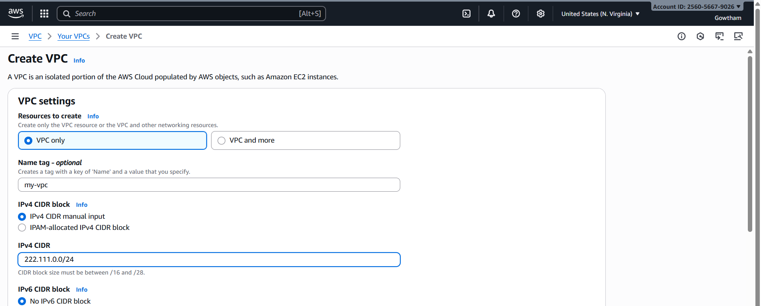
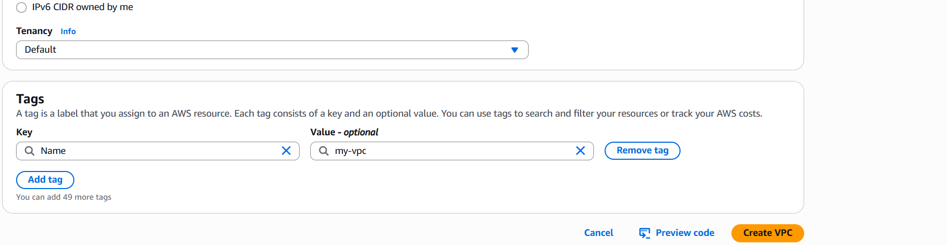
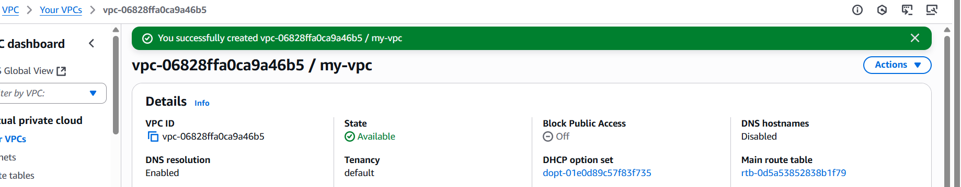

- Create two subnets: one public subnet and one private subnet.
Step 1: Goto VPCselect subnetcreate subnetselect VPC identer details
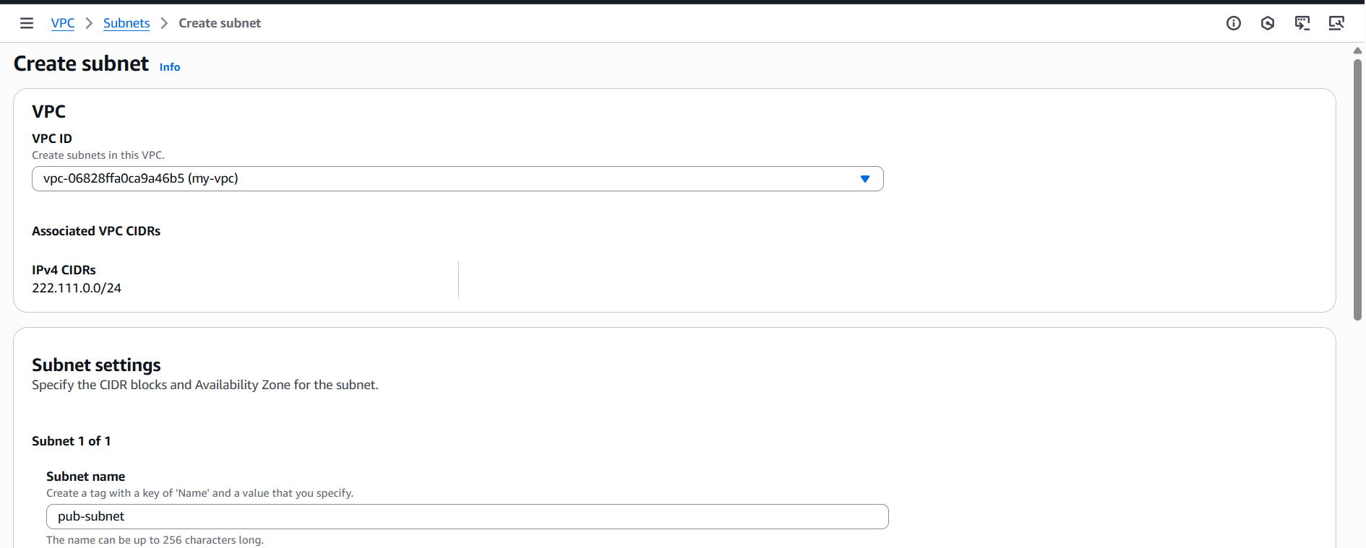
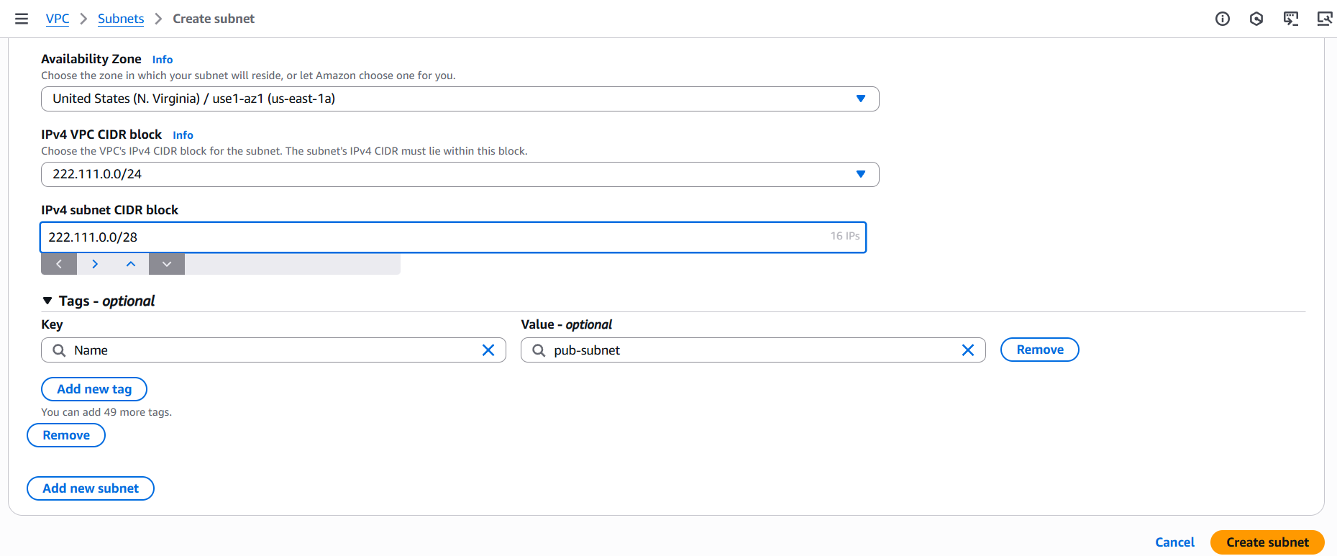
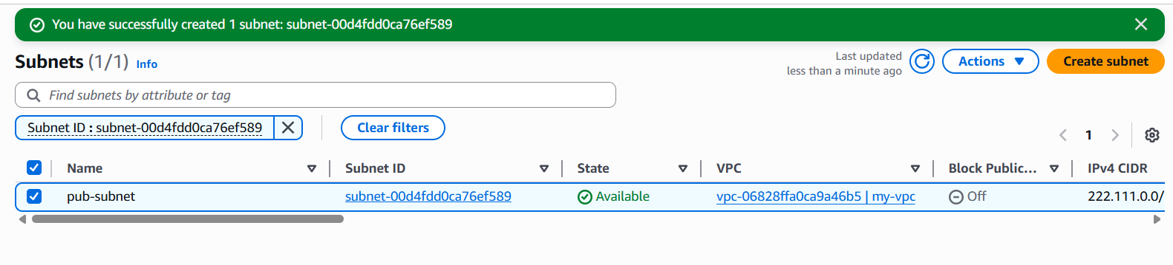
Step 2: Follow the same procedure without overlapping CIDR to create private subnet.
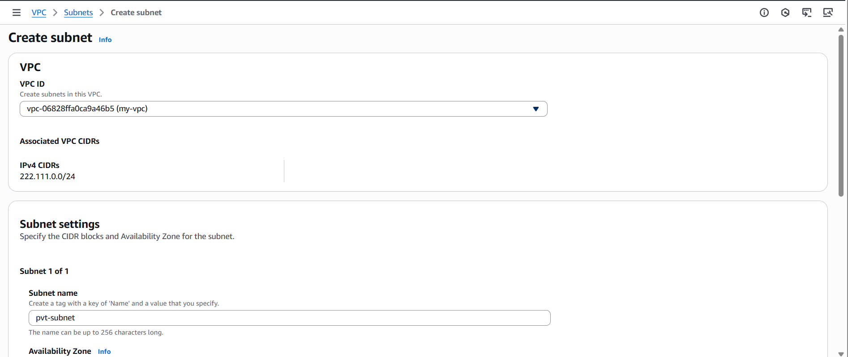
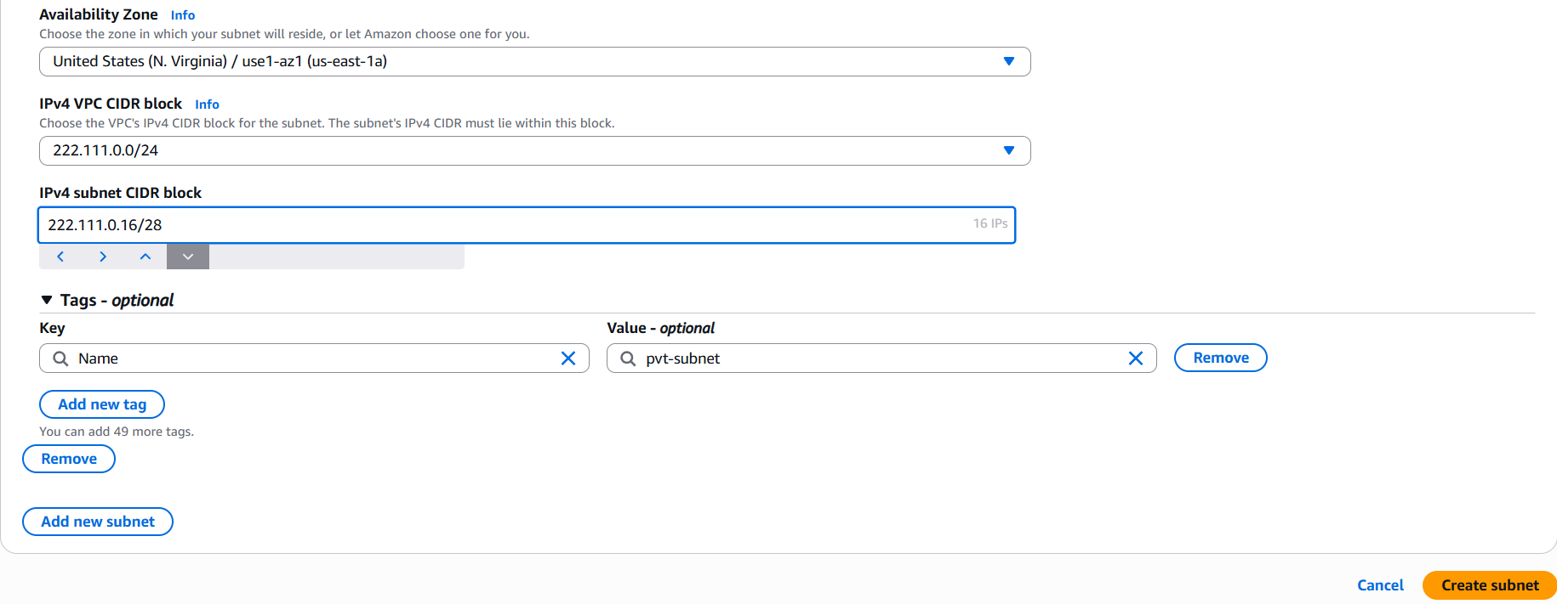
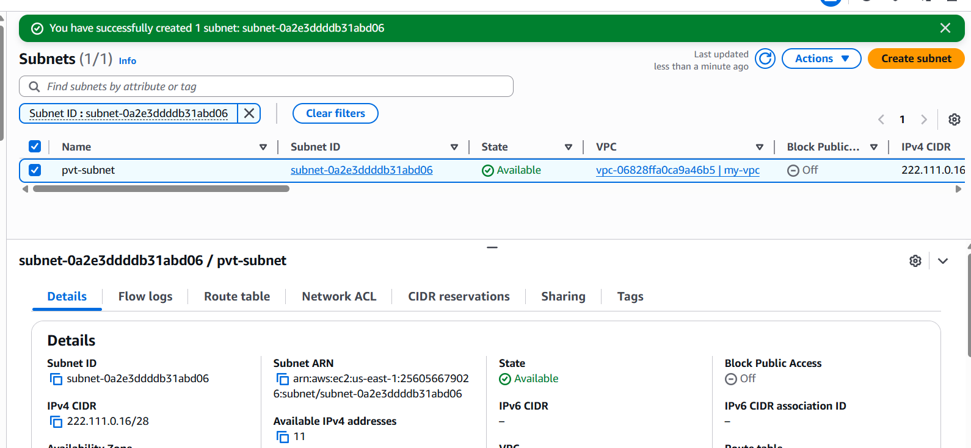

- Attach an IGW to the VPC.
Step 1: Goto VPCInternet gatewaycreate IGcreate
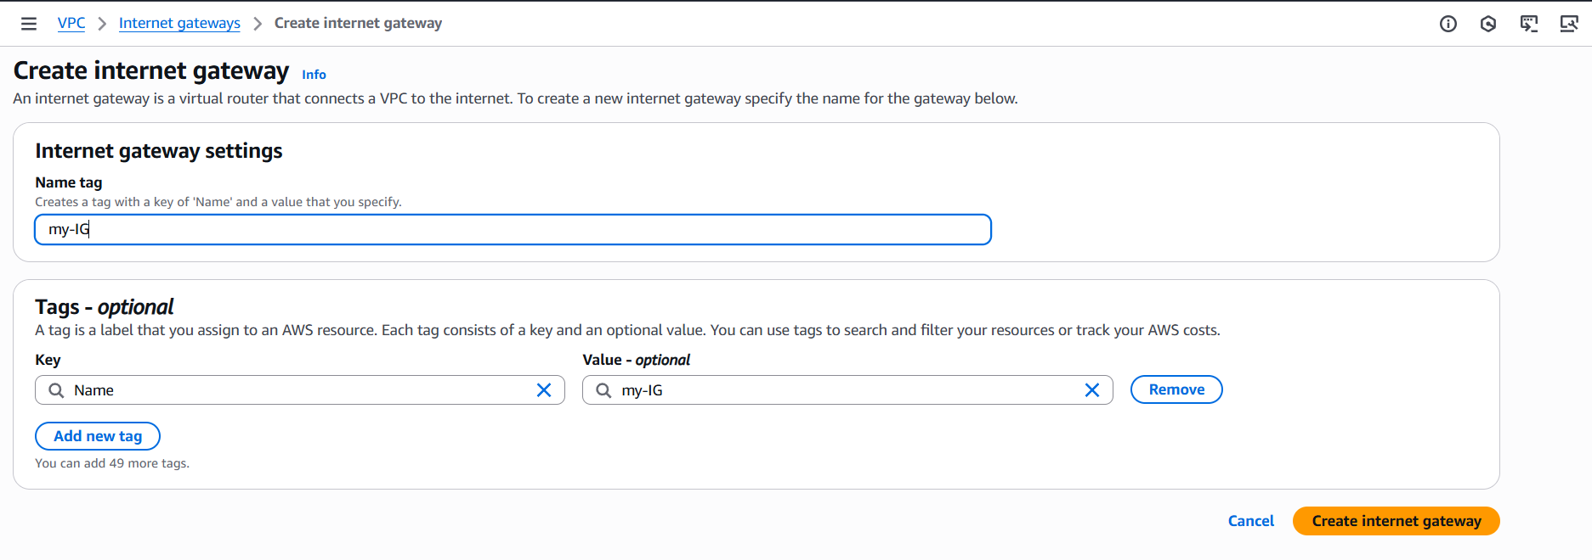
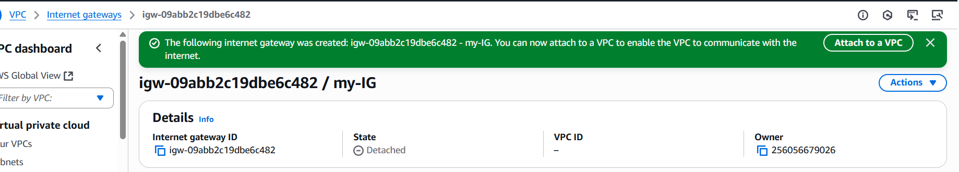
Step 2: select ActionsAttach to VPCselect VPCAttach IG.
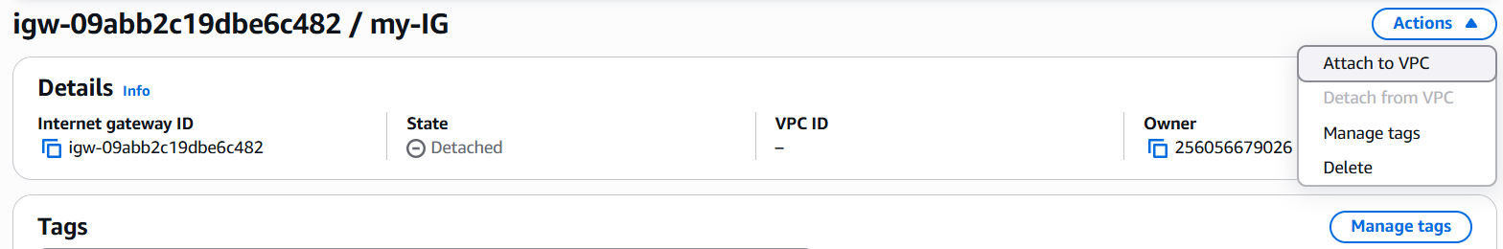
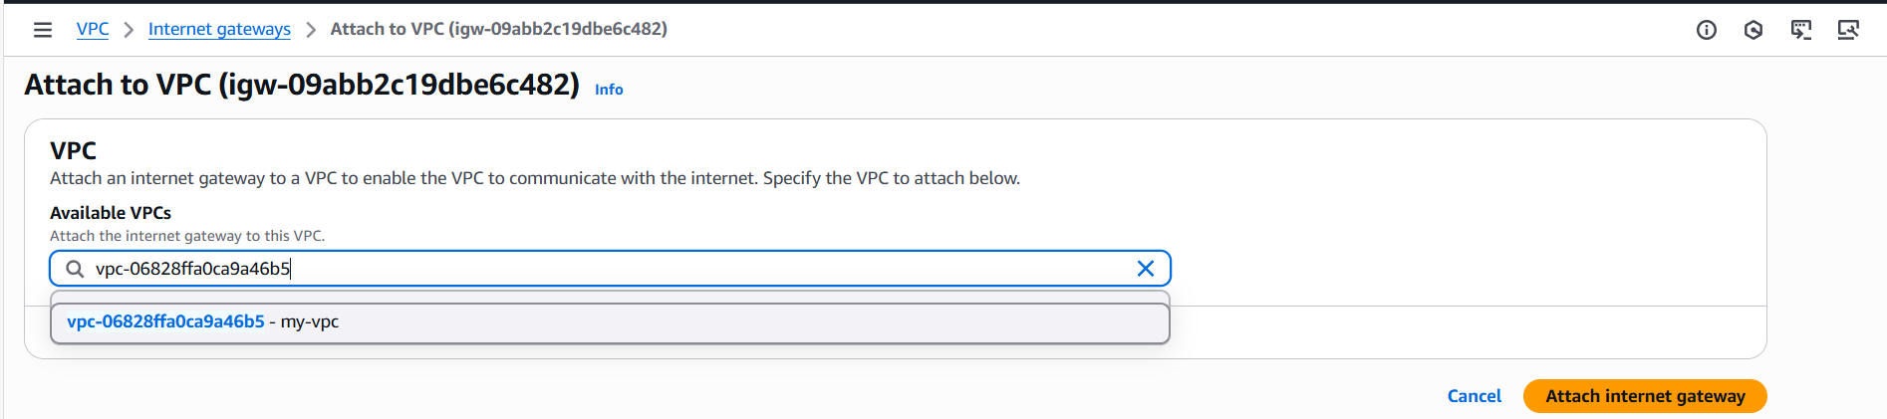
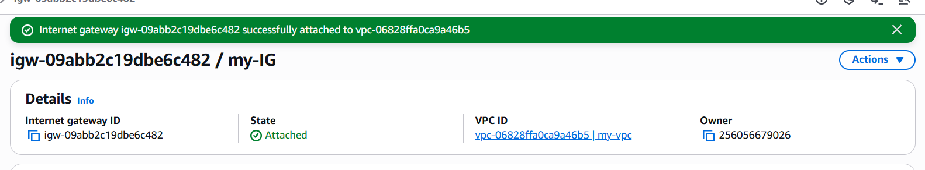

- Create one public route table (RT) and one private route table.
Step 1: Goto VPCRoute tablecreate RTselect VPC and enter detailsCreate.
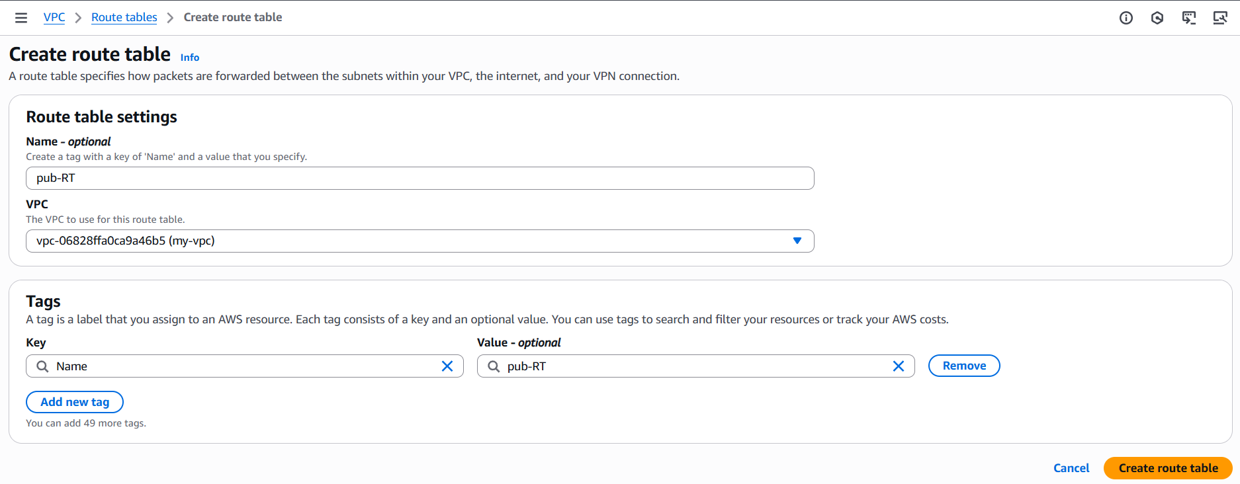
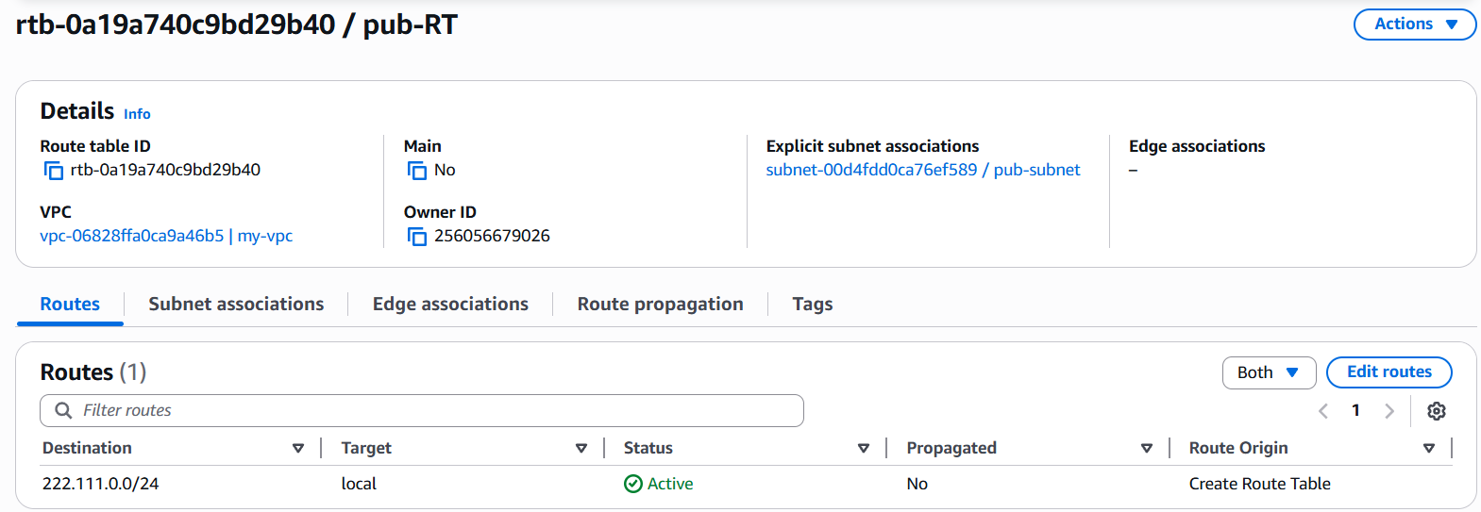

Step 2:Goto Subnet associationEdit SAselect public subnetsave association.
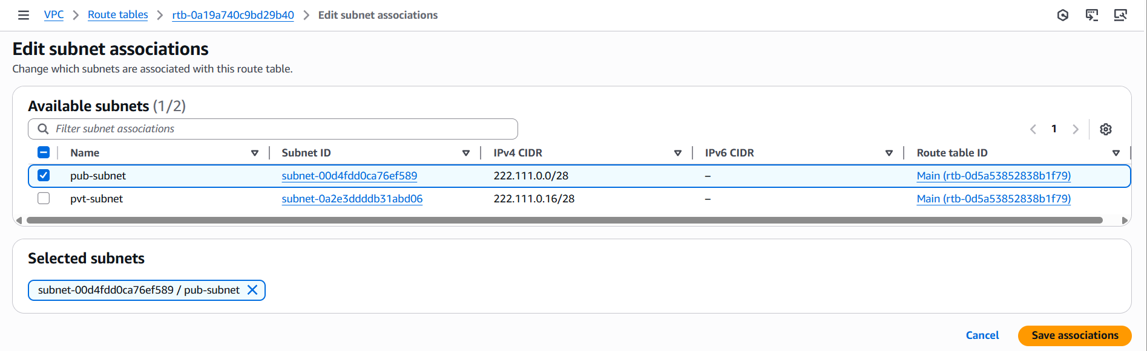
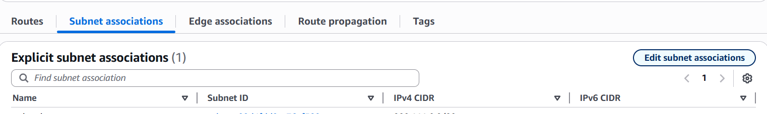
Step 3: Select RoutesEdit RoutesAdd Internet gatewaysave changes.
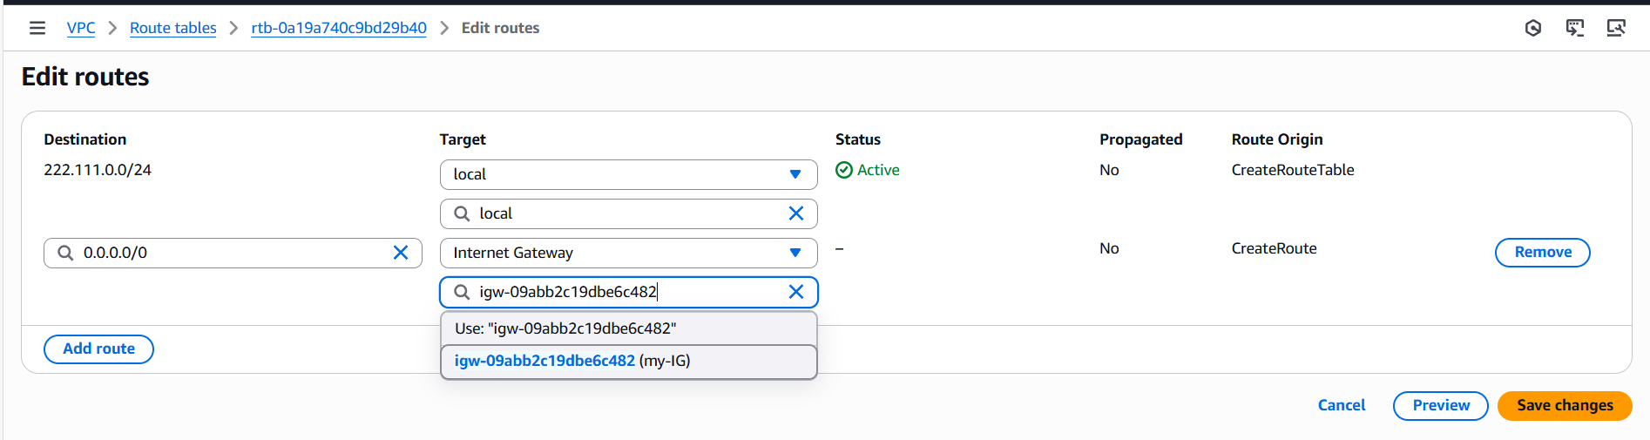
Step 4: Follow the steps 1 and 2 to create private route table.
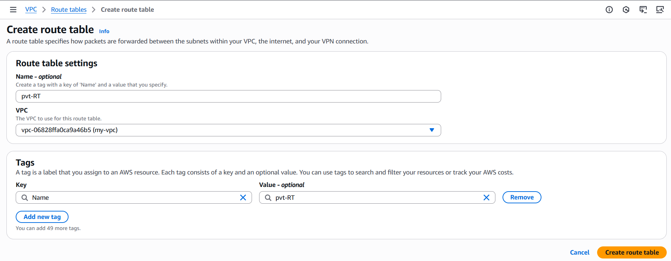
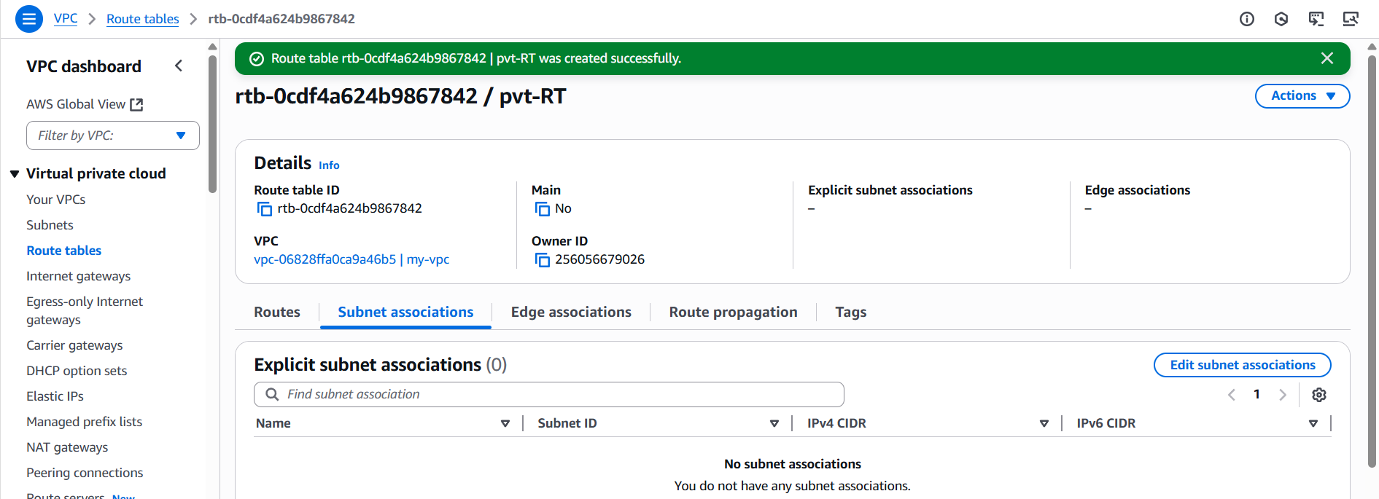
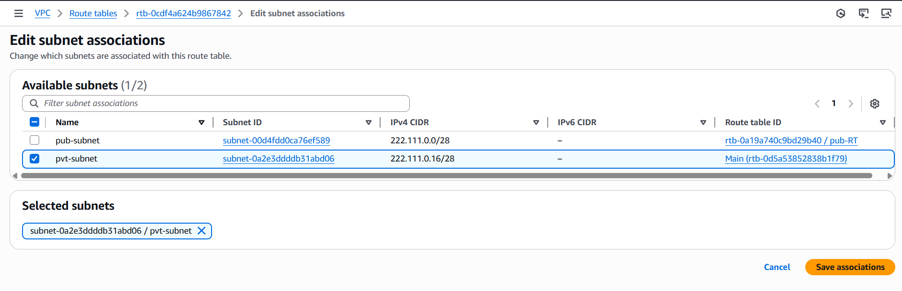
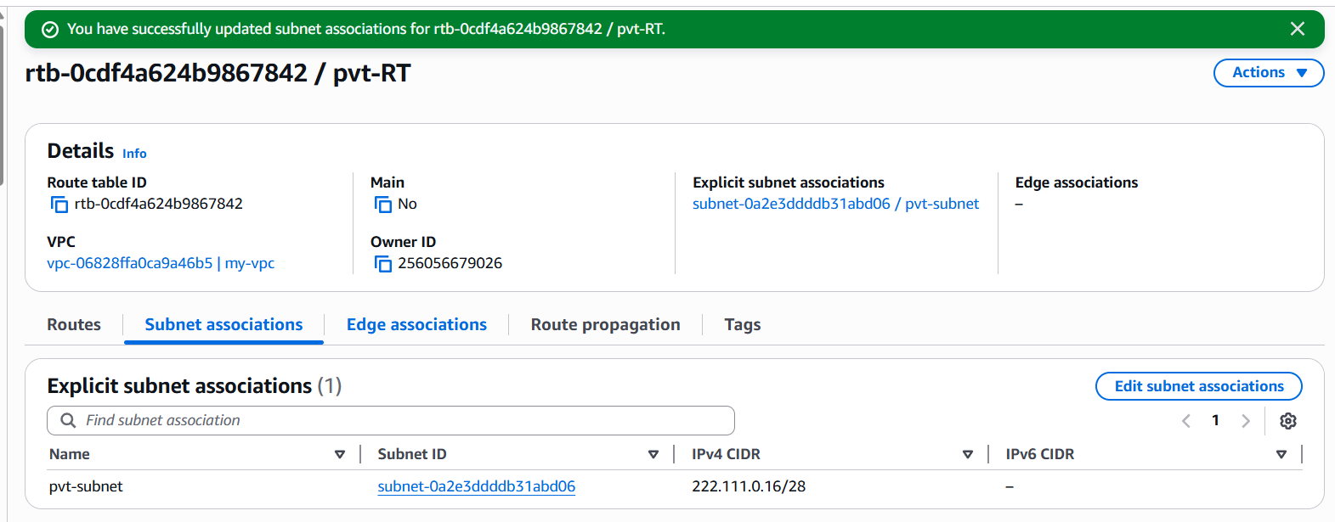

- Deploy a NAT gateway in the public subnet and attach the NAT gateway to the private subnet.
Step 1: Goto VPCNat gatewayscreate NGenter details and attach elastic ip
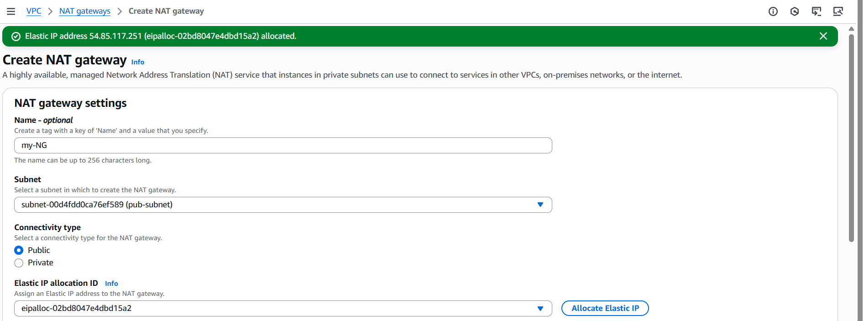
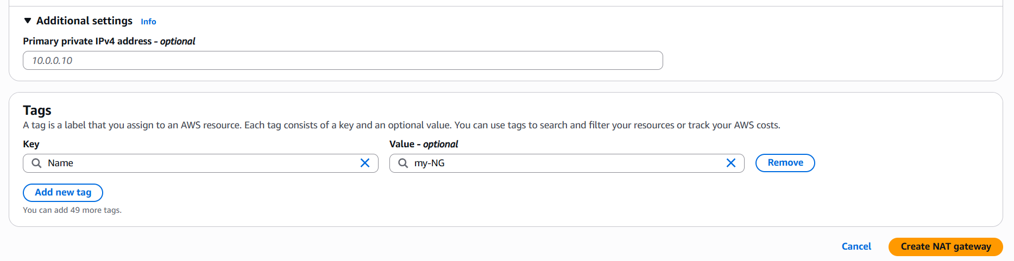
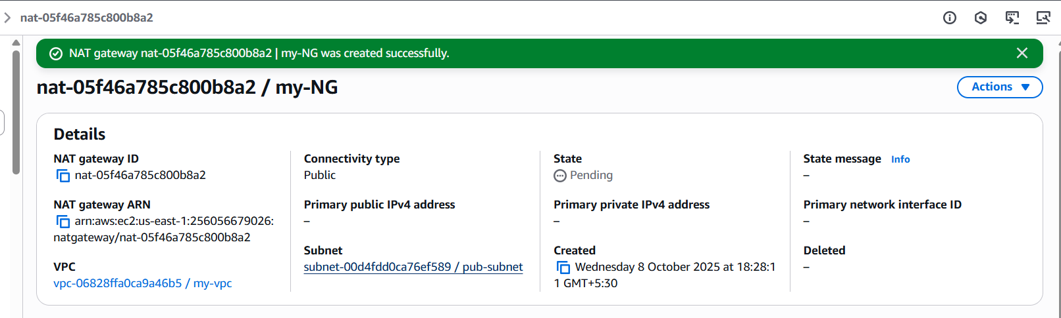
Step 2: Goto Route tableselect private RTRoutesEdit RoutesAdd Nat gatewaysave.
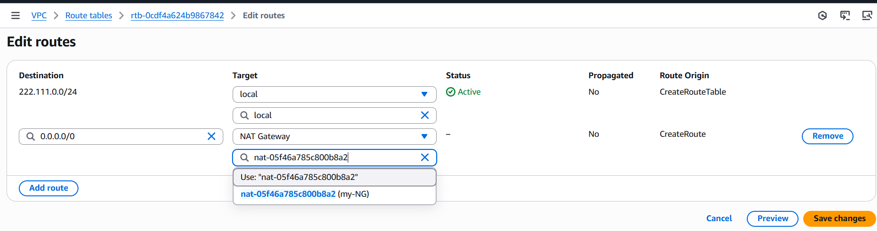

- Create two instances, one in the public subnet and one in the private subnet.
Step 1: Goto EC2Launch Instanceselect public subnet in network settingsLaunch instance.
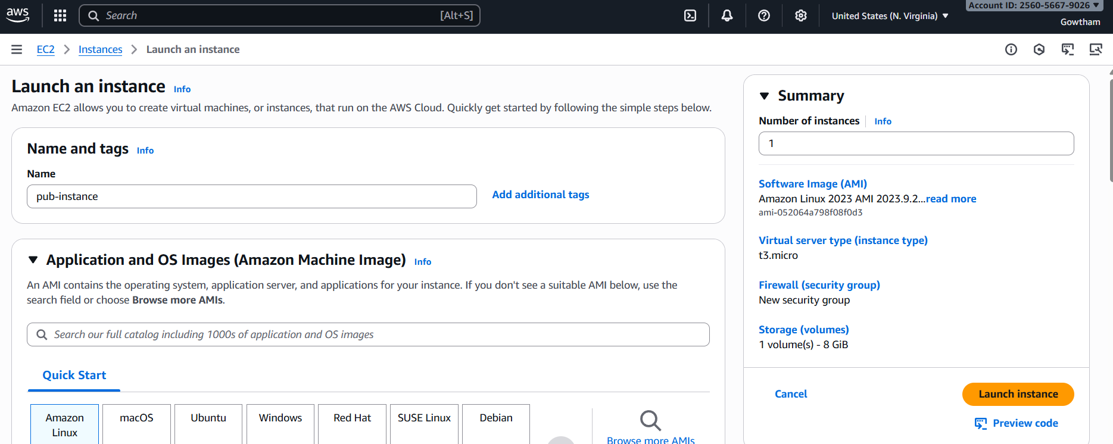
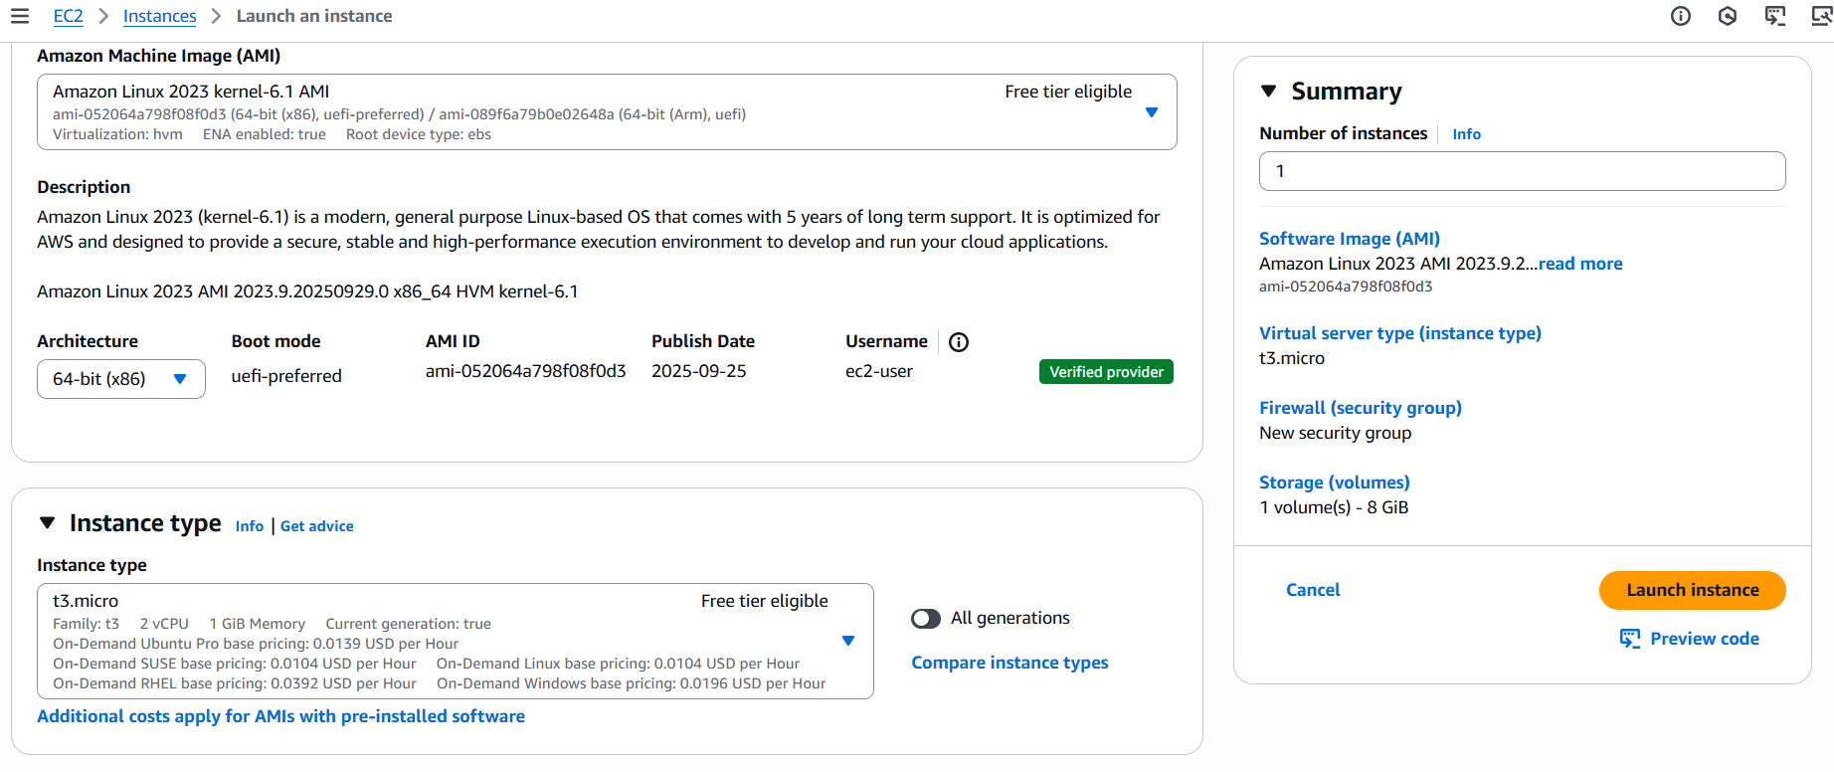
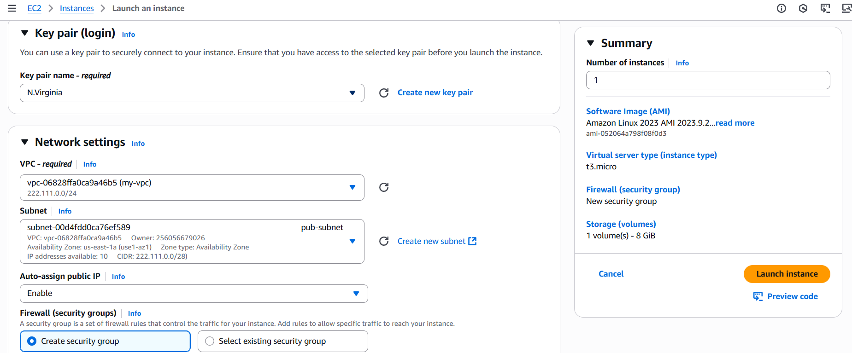

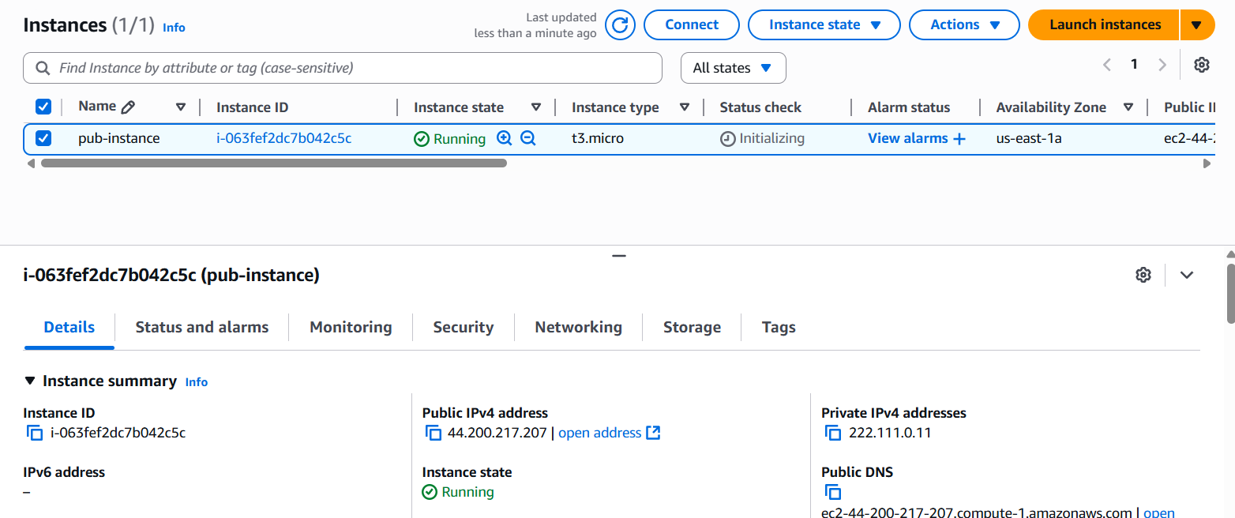
Step 2: Select launch Instanceselect private subnet in network settingsLaunch instance.
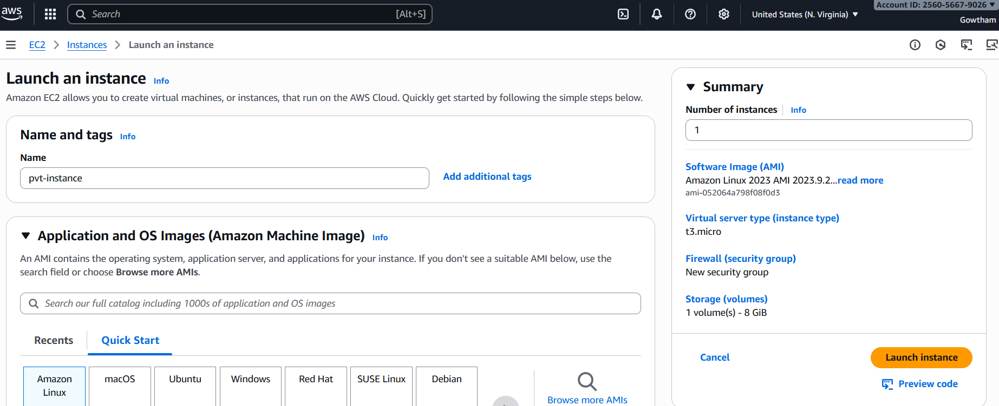
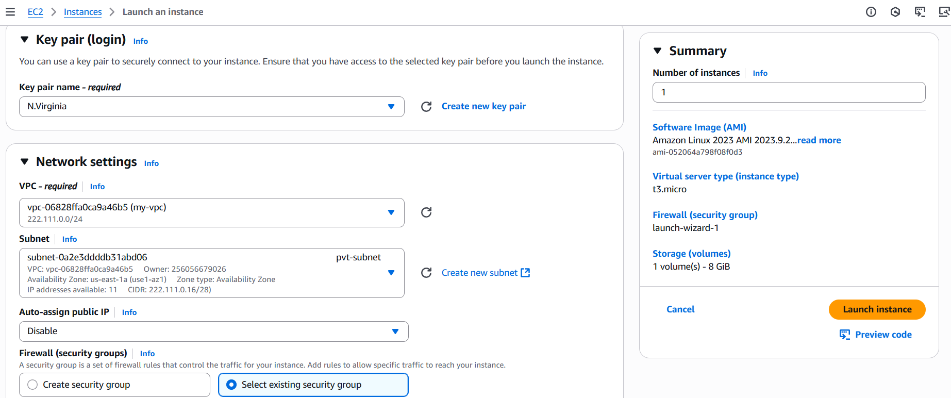

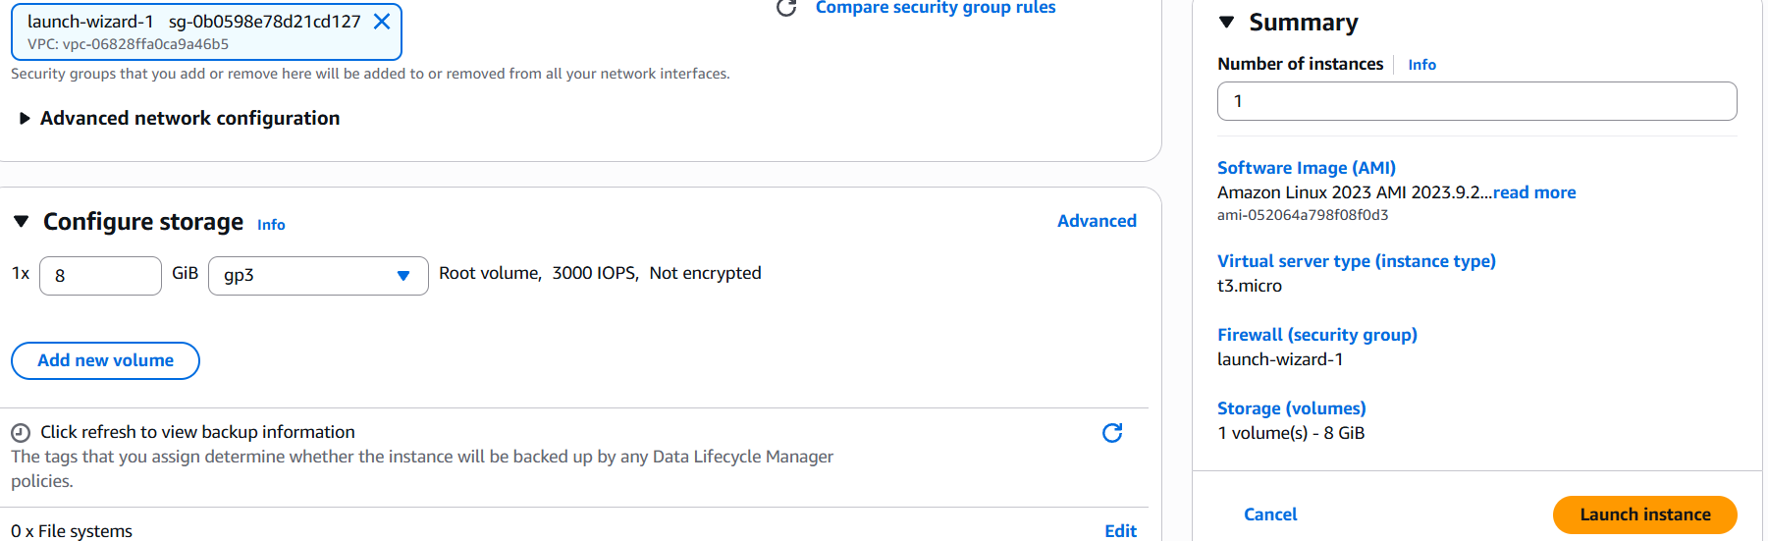
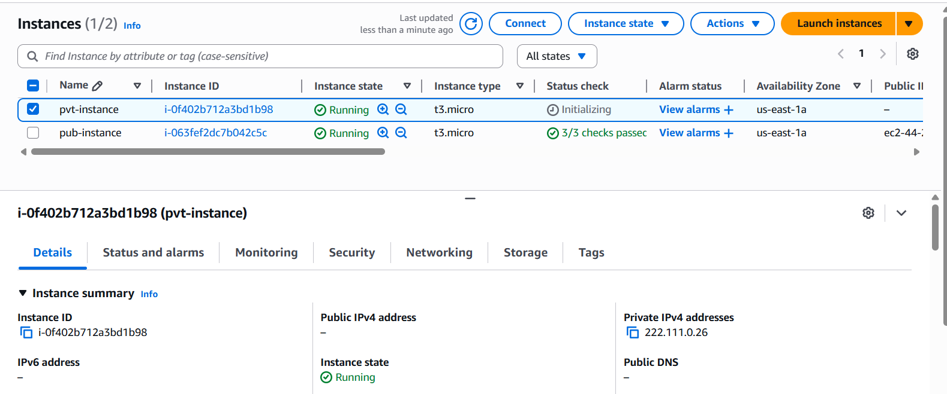

- Deploy Apache server on both EC2 instances with a sample index.html file.
Deploying Apache in public instance.
Step 1: Connect to public instance and install httpd(Apache).
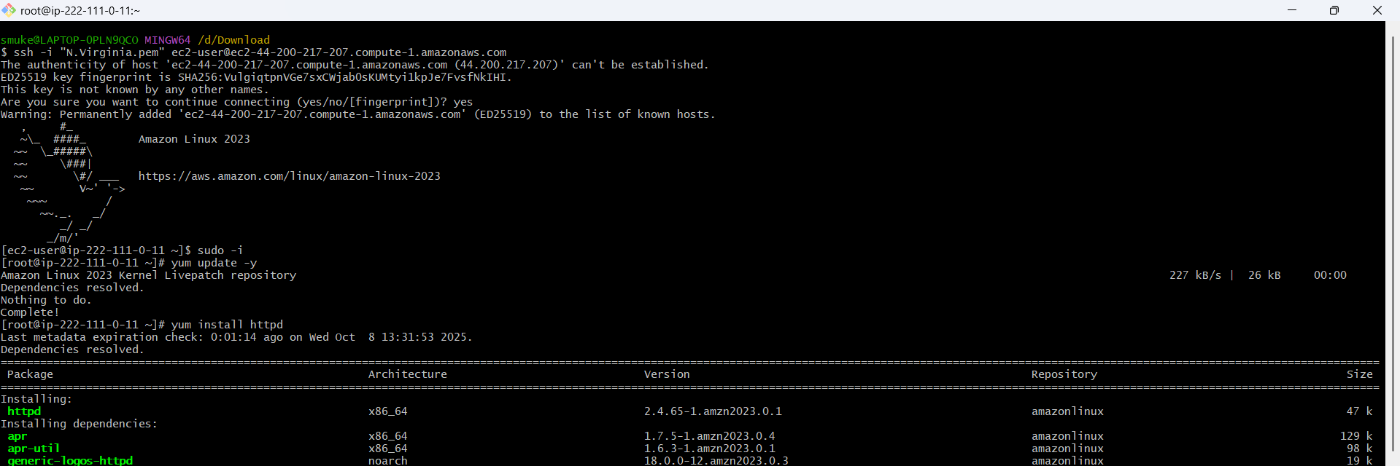
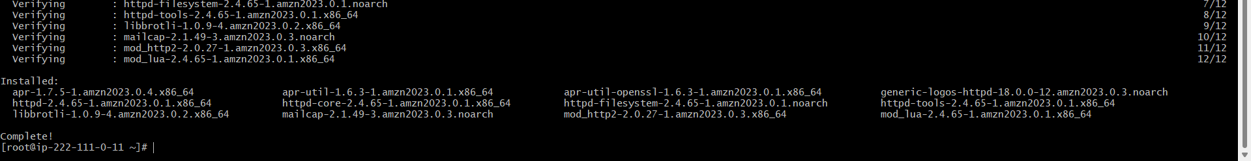

Step 2: Goto var/www/html/ create index.html and enter code.
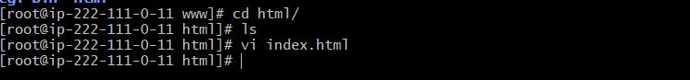
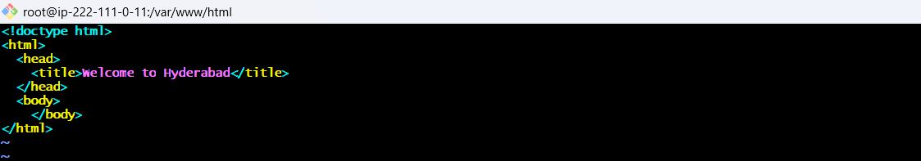
Step 3: Start apache using systemctl enable/start httpd.
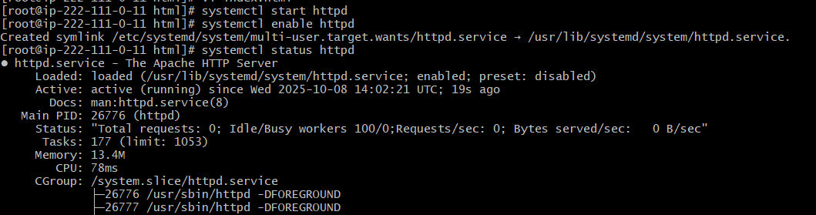
Step 4: Run public_ip:80 in browser.
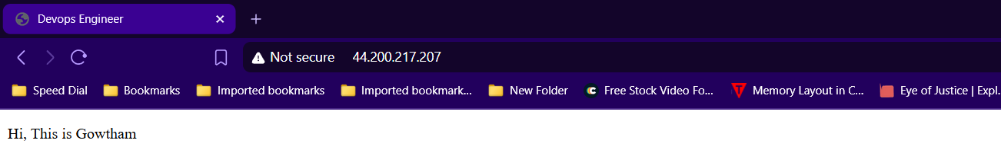
Deploying Apache in private instance.
Step 1: Copy the content of .pem key and create .pem file with same content in public instance.
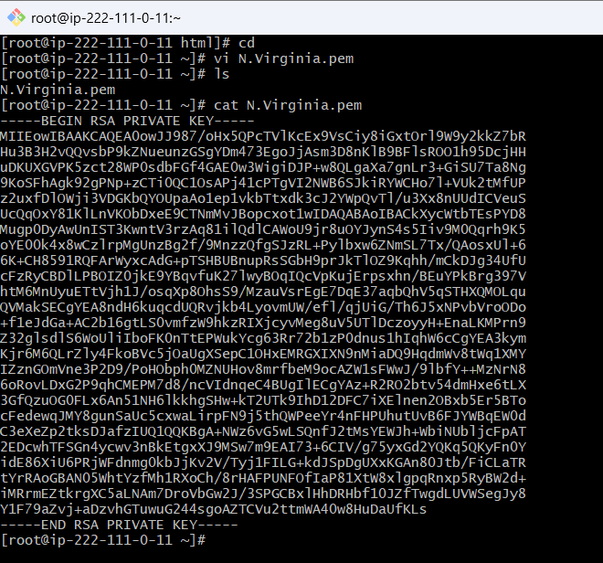
Step 2: Using Public instance as Jumper/Bastian server connect to private instance.
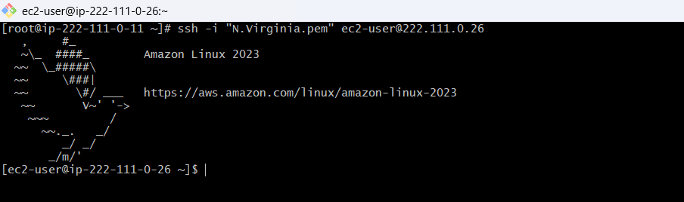
Step 3:install httpd(Apache), Deploy index.html file and start it.
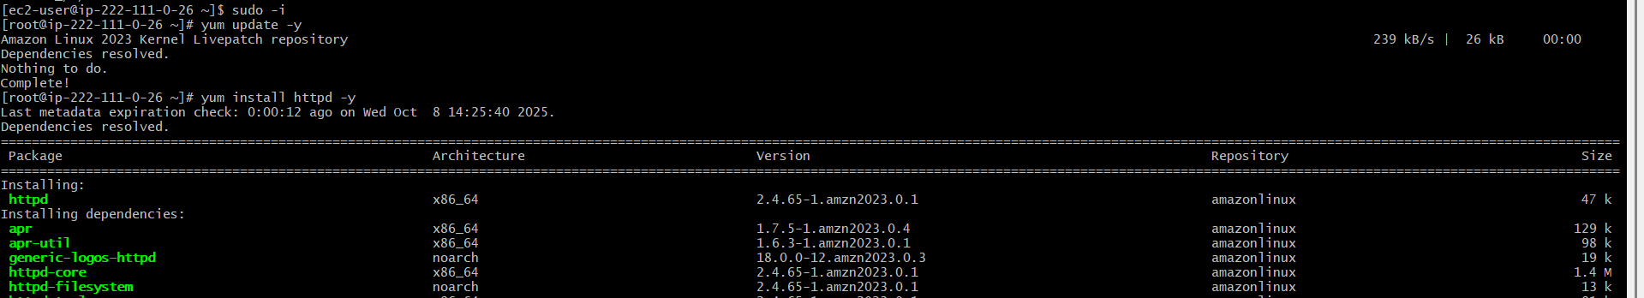
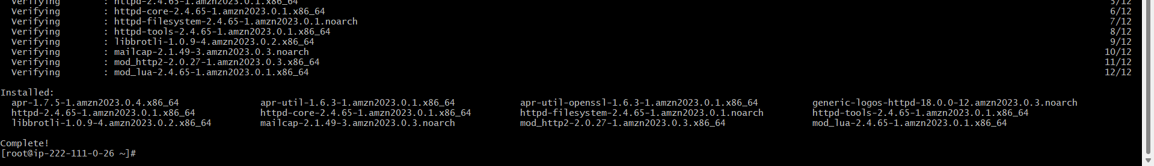
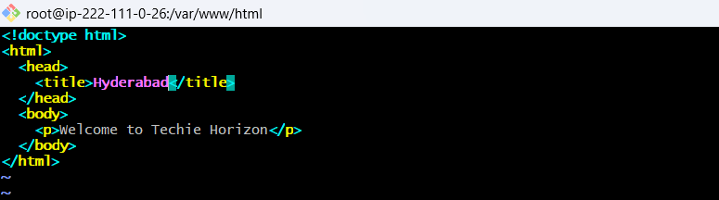
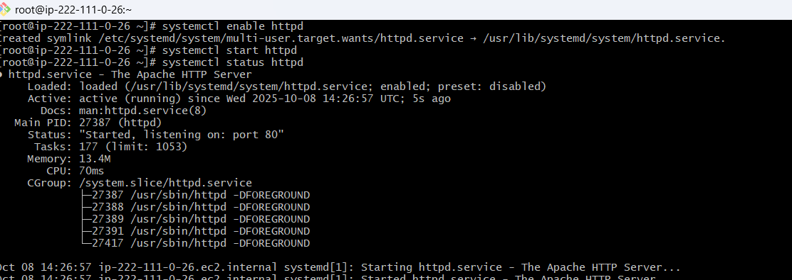

Step 4: Run curl private_ip:80.
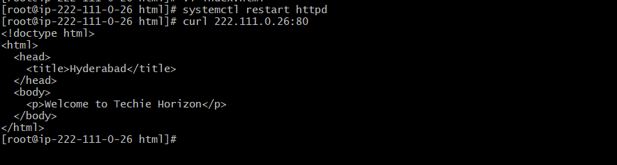

If you want to run in your browser use SSH Tunnel method.
Step 1: Run following command in new window ssh -i N.Virginia.pem -L 80:222.111.0.26:80 ec2-user@3.237.191.46.
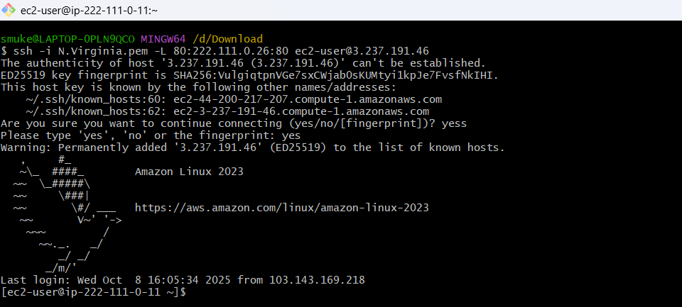
Step 2: Run localhost:80 in your browser.
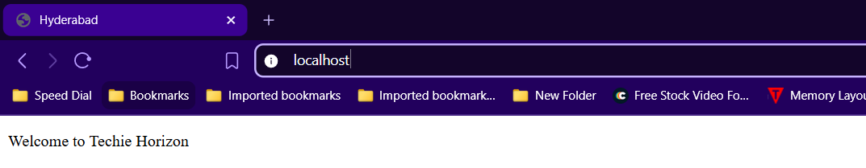

- Create one application load balancer and attach it to both EC2 instances.
Step 1: Goto EC2Load balancercreate LBselect LB typeEnter details
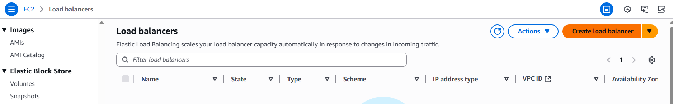
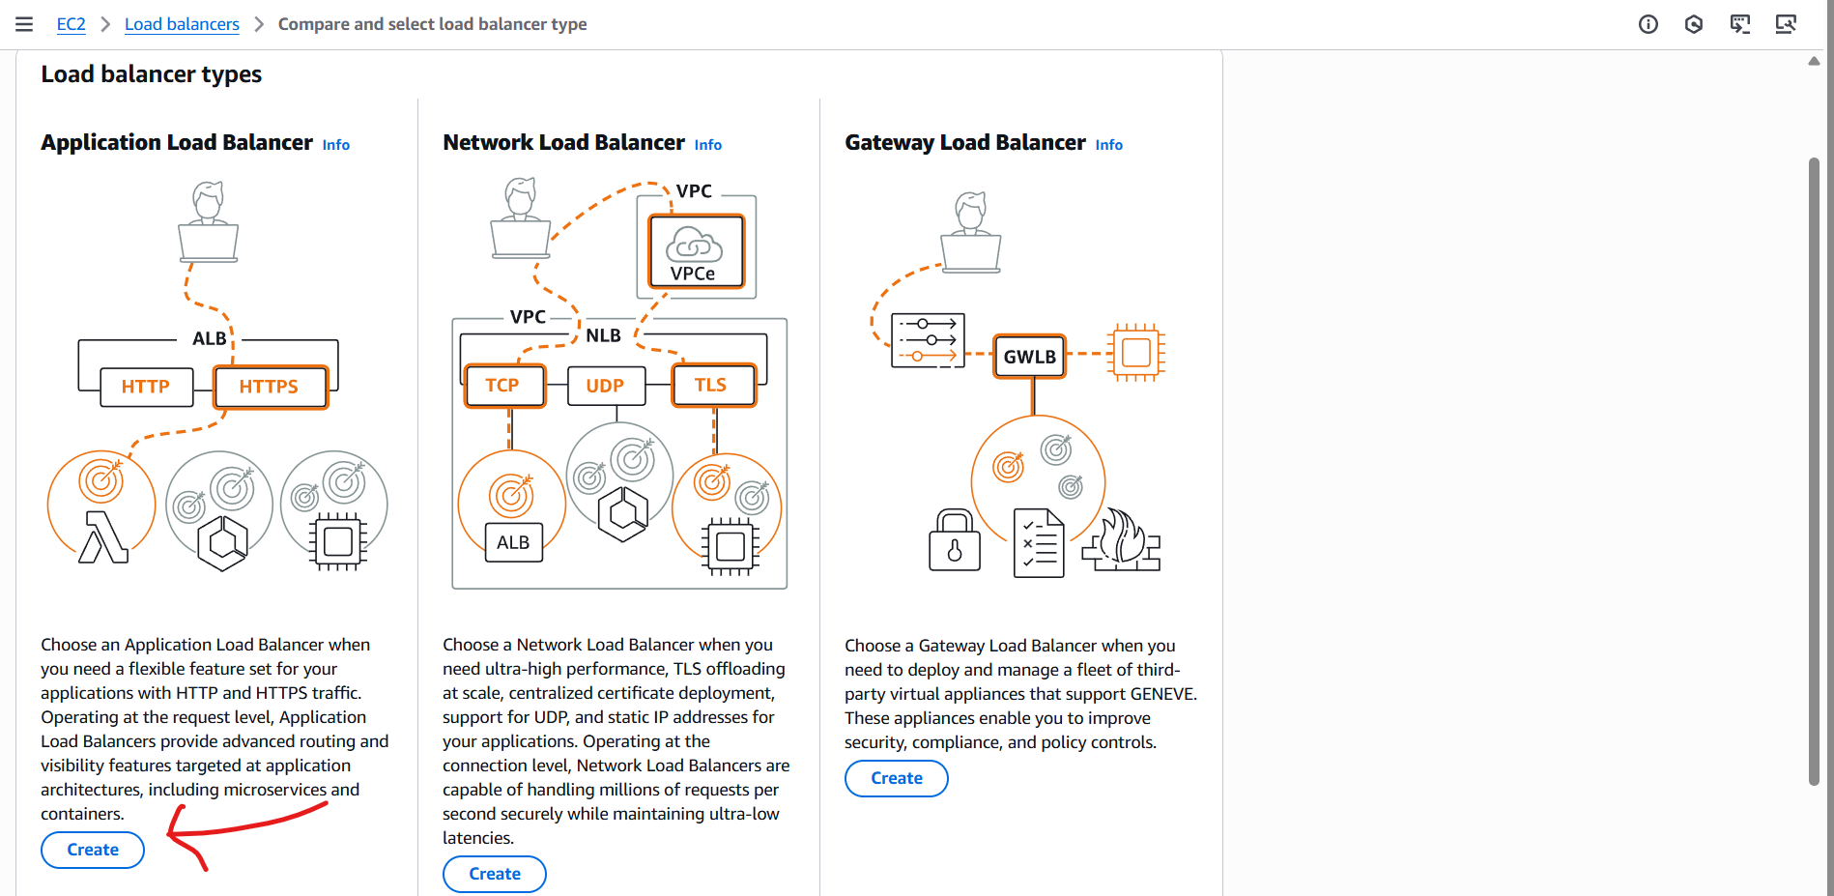
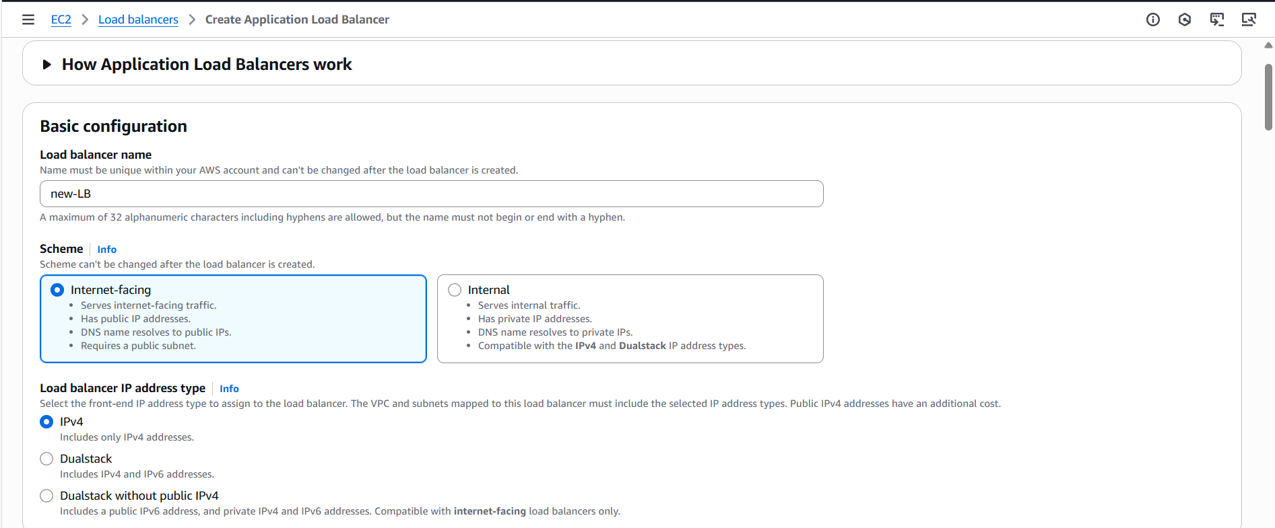
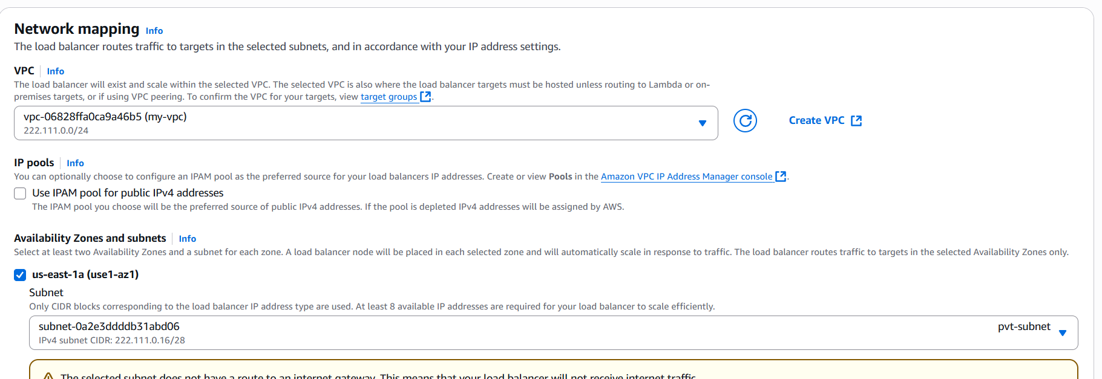
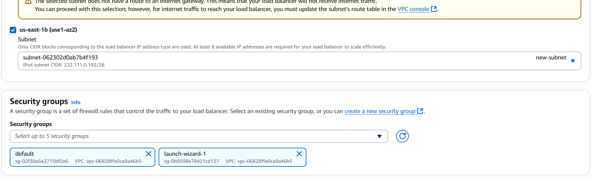
Step 2: select port and click create target group.
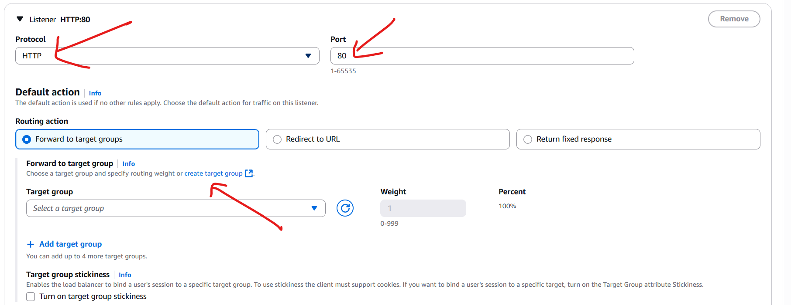

Step 3: select instancesgive nameselect ipv4 and your VPCnext.
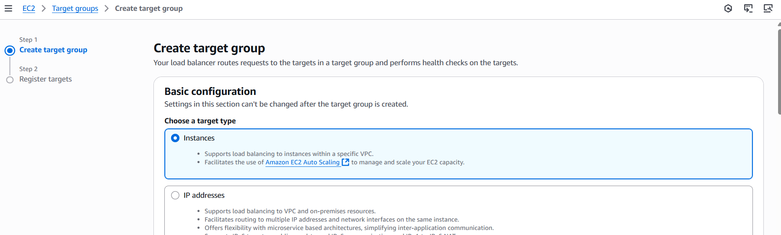
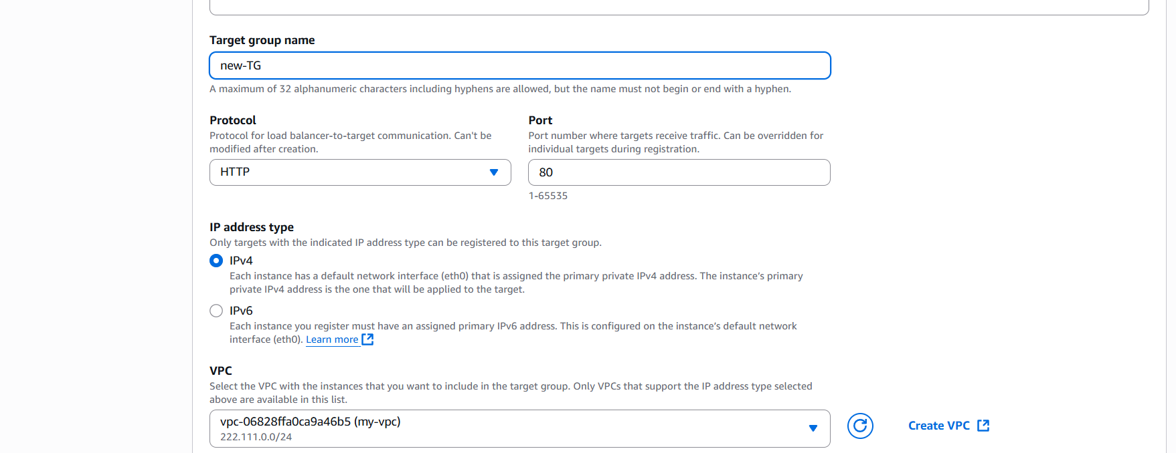
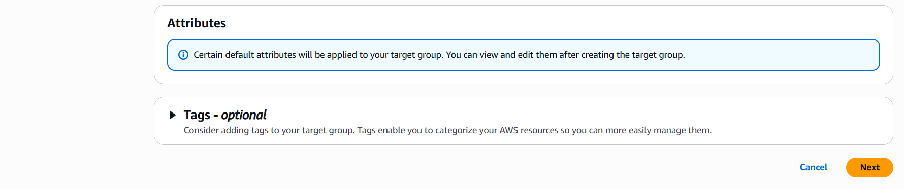
Step 4:Select the instances and select include as pending belowcreate.
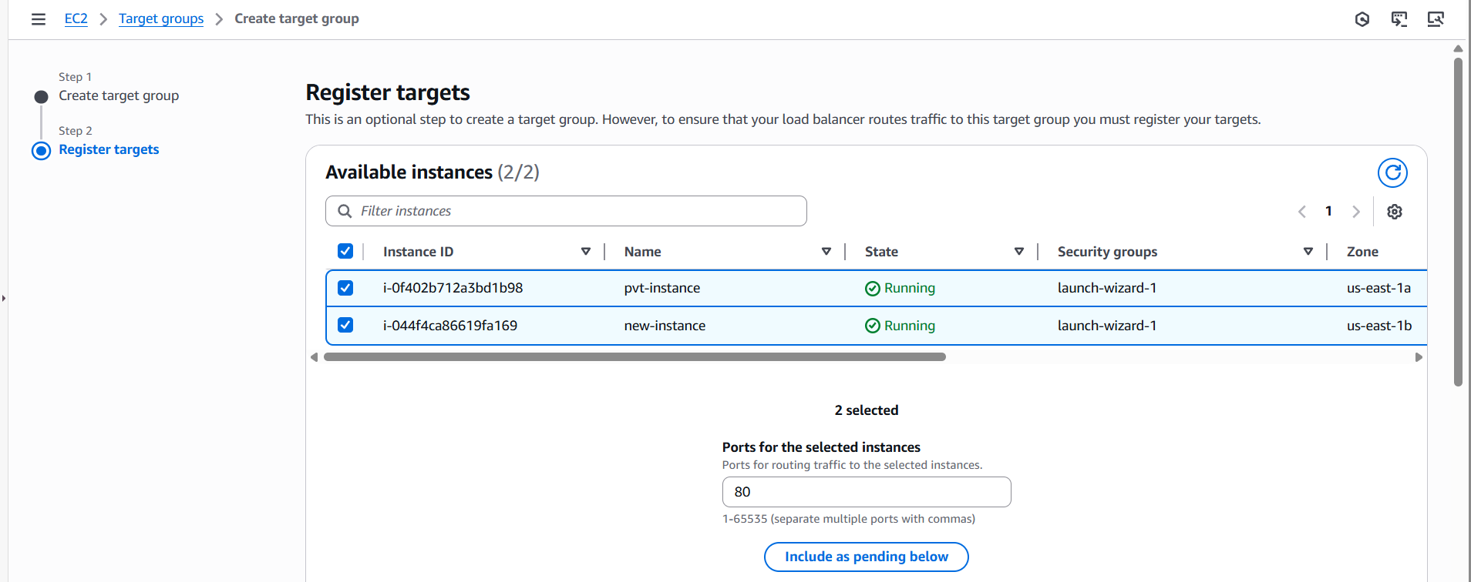
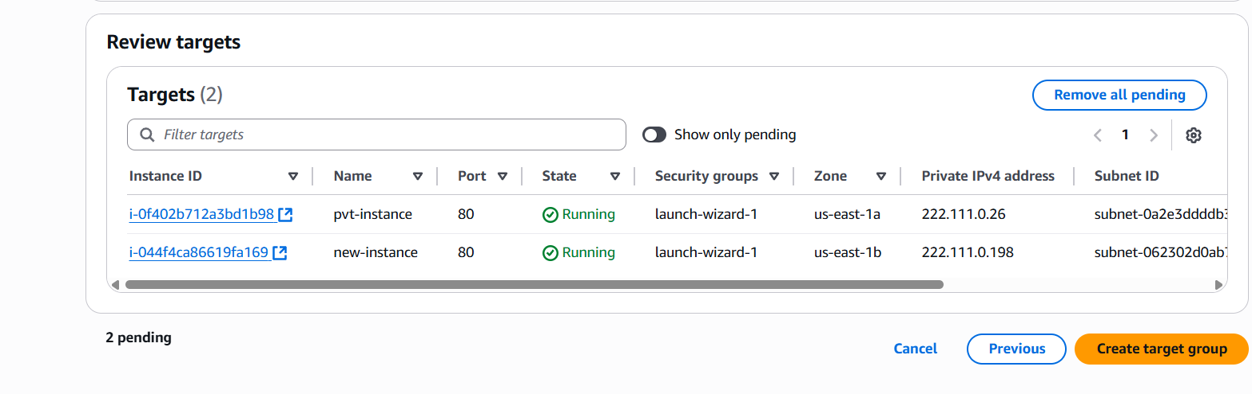
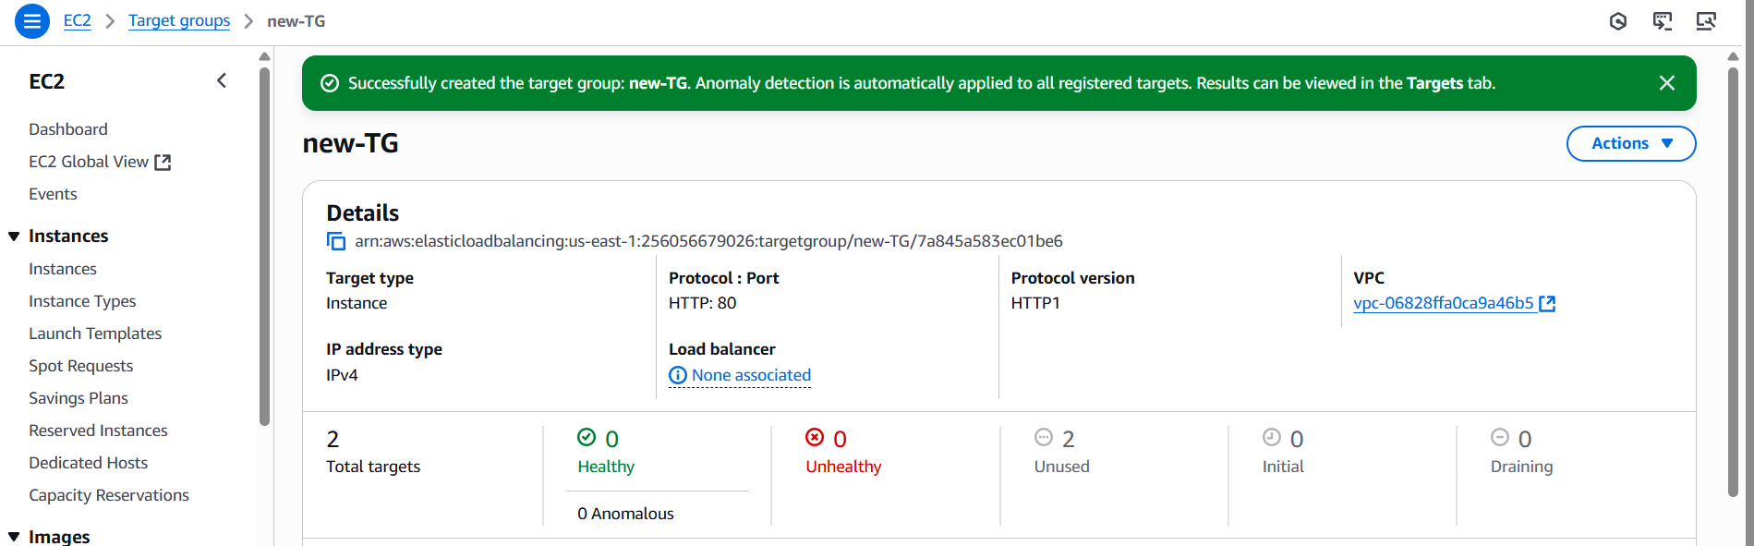

Step 5: Now comeback to Load balancer page and select the created target group.
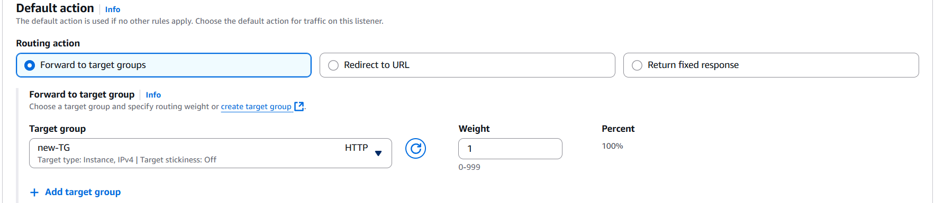
Step 6: click create Load Balancer.
